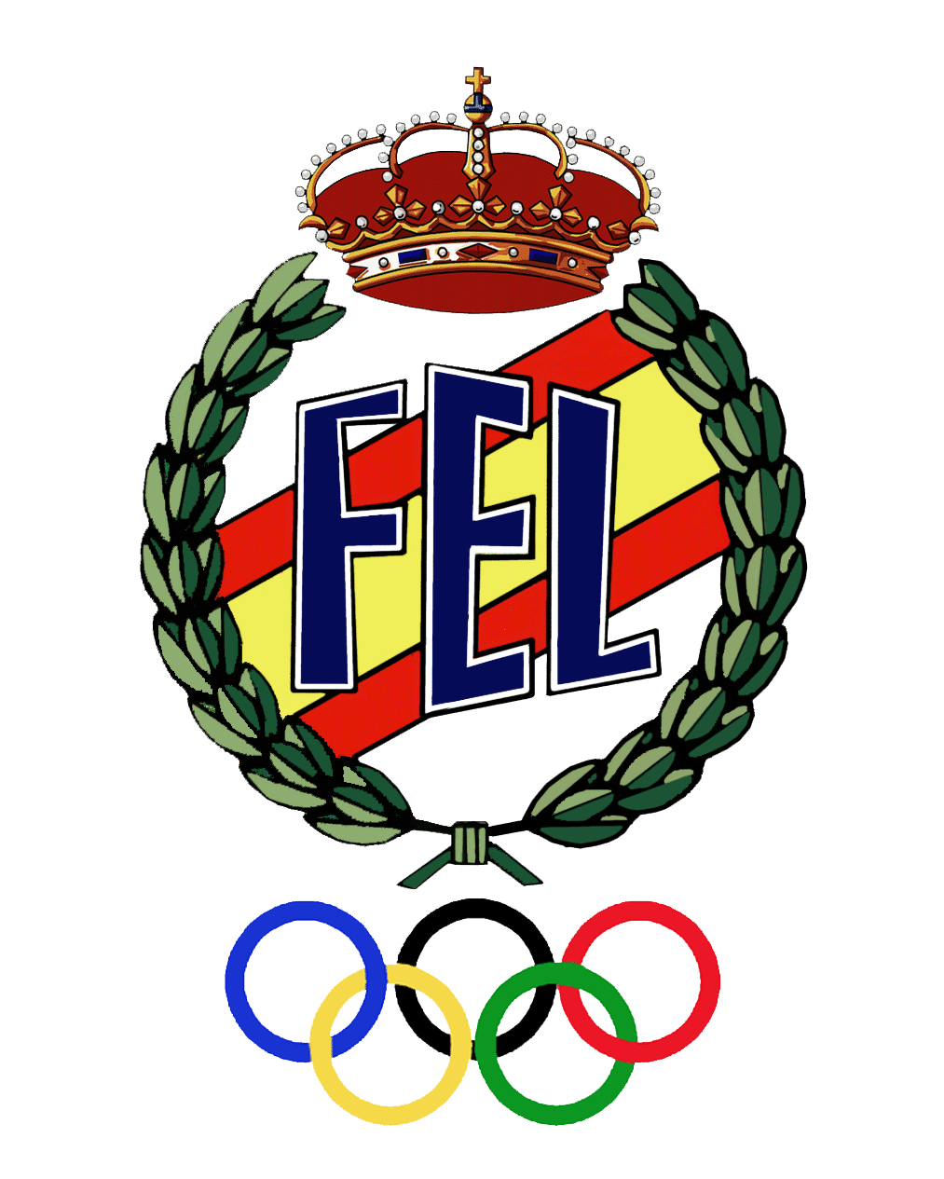
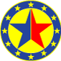

PROGRAM

European Sambo Championship Among Juniors (M-F) and Youth (M-F)
10-14 April, 2014 Caceres (Spain)
Youth: 1996-1997 /: Juniors 1994-1995

Thursday, April 10 : DAY 1
10.00-16.00 | Delegation arrival, Mandate Commission, accreditation, accommodation
16.00-17.00 | Referees seminar
17.00-18.00 | Representatives and coaches seminar
18.00-19.00 | Weigh-in: 48, 60, 75 kg (youth male)  40, 52, 65 kg (youth female)  48, 62, 82 kg (juniors male)  44, 56, 68 kg (juniors female)
Friday, April 11 : DAY 2
10.00 | Preliminaries: 48, 60, 75 kg (youth male)  40 ,52, 65 kg (youth female)  48, 62, 82 kg (juniors male)  44, 56, 68 kg (juniors female)
15.00-16.00 | Weigh-in: 52, 65, 81, +87kg (youth male)  44, 56, 70, +75 kg (youth female)  52, 68, 90, +100kg (juniors male)  48, 60, 72, +80kg (juniors female)
17.30  18.00 | Opening ceremony  Finals : 48, 60, 75 kg (youth male)  40, 52, 65 kg (youth female)  48, 62, 82 kg (juniors male)  44, 56, 68 kg (juniors female)  Awarding of the champions and winners
Saturday, April 12 : DAY 3
10.00 | Preliminaries: : 52, 65, 81, +87kg (youth male)  44, 56, 70,+75 kg ( youth female)  52, 68, 90, +100kg (juniors male)  48, 60, 72, +80kg (juniors female)
15.00-16.00 | Weigh-in : 56, 70, 87kg (youth male)  48, 60, 75kg (youth female)  57, 74, 100kg (juniors male)  52, 64, 80kg (juniors female)
18.00 | Finals: 52, 65, 81, +87kg (youth male)  44, 56, 70, +75 kg ( youth female)  52, 68, 90, +106kg (juniors male)  48, 60, 72, +80kg (juniors female)
Sunday, April 13 : DAY 4
10.00 | Preliminaries: : 56, 70, 87kg (youth male)  48, 60, 75kg (youth female)  57, 74, 100kg (juniors male)  52, 64, 80kg (juniors female)
16.00 | Finals: 56, 70, 87kg (youth male)  48, 60, 75kg (youth female)  57, 74, 100kg (juniors male)  52, 64, 80kg (juniors female)
17:00 | Closing Ceremony of the European SAMBO Championship
20:00 | Official Dinner
Monday, April 14 : DAY 5 | Departure of delegations

