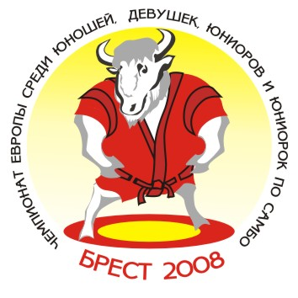 European Youth and Junior Sambo Championships 2008
Team’s results

Brest/ Republic of Belarus Women (17-18) May 16-18, 2008

№ п/п | Команды | ВЕСОВАЯ КАТЕГОРИЯ |  |  |  |  |  |  |  |  |  | Всего очков | Место
№ п/п | Команды | 40 | 44 | 48 | 52 | 56 | 60 | 65 | 70 | 75 | +75 | Всего очков | Место
1. | RUS | 7 | 1 | 7 | 3 | 7 | 5 | 3 | 1 | 5 | 1 | 40 | II
2. | BLR | 5 | 7 | 1 | 7 | 5 |  | 7 | 7 | 7 | 3 | 49 | I
3. | UKR |  | 3 | 3 | 5 |  |  | 3 | 3 | 3 | 7 | 27 | III
4. | LAT |  |  |  | 3 | 1 | 1 | 1 | 5 | 1 |  | 12 | 6
5. | LTU |  |  | 5 | 1 | 3 | 3 |  | 1 | 3 | 1 | 17 | 5
6. | BUL |  |  |  | 1 |  | 7 |  |  |  |  | 8 | 7
7. | ROM |  |  |  |  | 3 |  | 5 |  |  |  | 8 | 8
8. | MDA |  | 5 | 3 |  | 1 | 3 |  | 3 |  | 3 | 18 | 4
9. | GER |  | 3 |  |  |  |  |  |  |  |  | 3 | 10
10. | CZE |  | 1 |  |  |  |  |  |  |  |  | 1 | 11-12
11. | EST |  |  |  |  |  |  |  |  |  | 5 | 5 | 9
12. | ARM |  |  |  |  |  | 1 |  |  |  |  | 1 | 11-12

Главный судья_________________________(V.Bukhval) Главный секретарь ______________________(Y.Shoia)

